**Week-2: (Module 3)**

**PL/SQL Programming**

**Exercise 1: Control Structures**

CREATE TABLE Customers (

    CustomerID NUMBER PRIMARY KEY,

    Name VARCHAR2(100),

    DOB DATE,

    Balance NUMBER,

    LastModified DATE

);

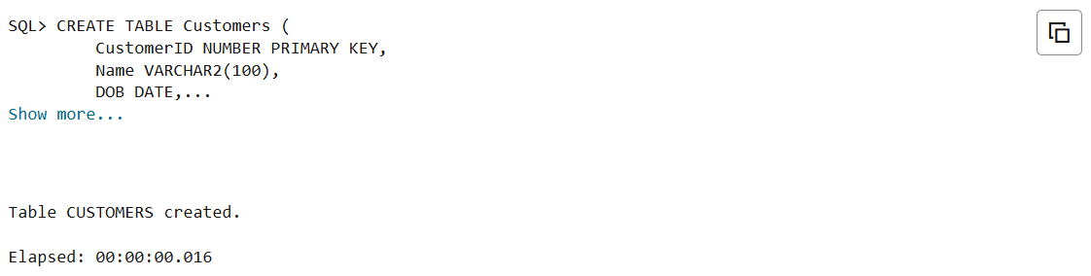

CREATE TABLE Loans (

    LoanID NUMBER PRIMARY KEY,

    CustomerID NUMBER,

    LoanAmount NUMBER,

    InterestRate NUMBER,

    StartDate DATE,

    EndDate DATE,

    FOREIGN KEY (CustomerID) REFERENCES Customers(CustomerID)

);

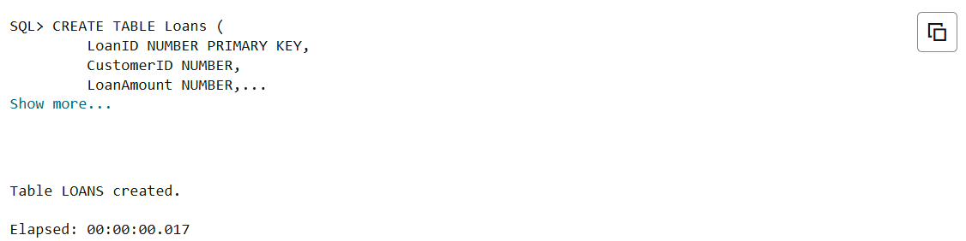

INSERT INTO Customers (CustomerID, Name, DOB, Balance, LastModified)

VALUES (1, 'Uma Yashaswi', TO_DATE('2004-07-29', 'YYYY-MM-DD'), 12000, SYSDATE);

INSERT INTO Customers (CustomerID, Name, DOB, Balance, LastModified)

VALUES (2, 'Priya Darshini', TO_DATE('2008-10-25', 'YYYY-MM-DD'), 9000, SYSDATE);

INSERT INTO Customers (CustomerID, Name, DOB, Balance, LastModified)

VALUES (3, 'Ravi Kumar', TO_DATE('1950-10-25', 'YYYY-MM-DD'), 50000, SYSDATE);

SELECT * from CUSTOMERS;

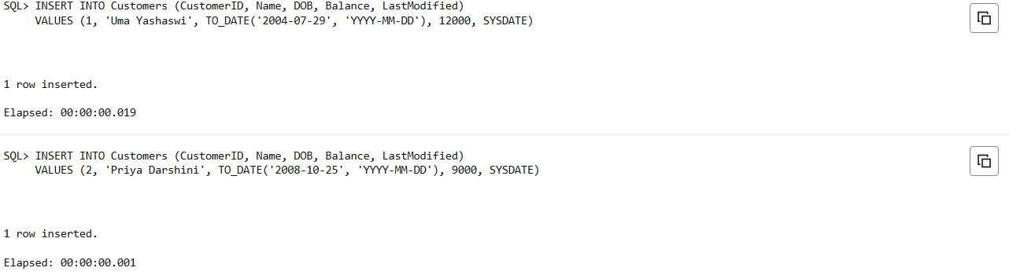

INSERT INTO Loans (LoanID, CustomerID, LoanAmount, InterestRate, StartDate, EndDate)

VALUES (1, 1, 5000, 6, SYSDATE, ADD_MONTHS(SYSDATE, 1));

INSERT INTO Loans (LoanID, CustomerID, LoanAmount, InterestRate, StartDate, EndDate)

VALUES (2, 2, 7000, 7, SYSDATE, ADD_MONTHS(SYSDATE, 6));

INSERT INTO Loans (LoanID, CustomerID, LoanAmount, InterestRate, StartDate, EndDate)

VALUES (3, 3, 12000, 7, SYSDATE, ADD_MONTHS(SYSDATE, 6));

SELECT * from LOANS;

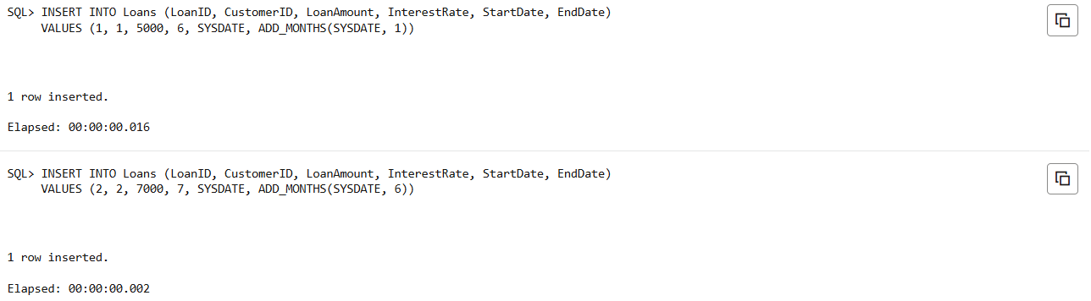

COMMIT;

**-- scenerio 1 --**

BEGIN

  FOR cust IN (

    SELECT c.CustomerID, c.DOB, l.LoanID

    FROM Customers c

    JOIN Loans l ON c.CustomerID = l.CustomerID

  ) LOOP

    IF MONTHS_BETWEEN(SYSDATE, cust.DOB) / 12 > 60 THEN

      UPDATE Loans

      SET InterestRate = InterestRate - 1

      WHERE LoanID = cust.LoanID;

    END IF;

  END LOOP;

  COMMIT;

END;

/

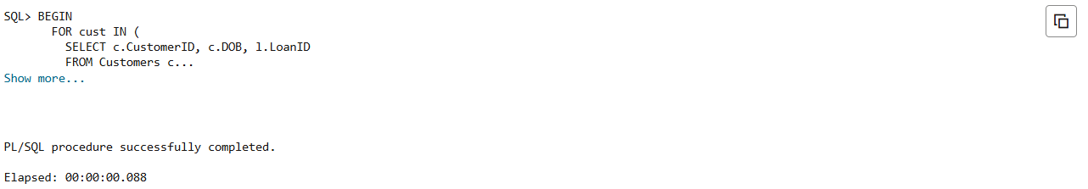

SELECT * from Loans;

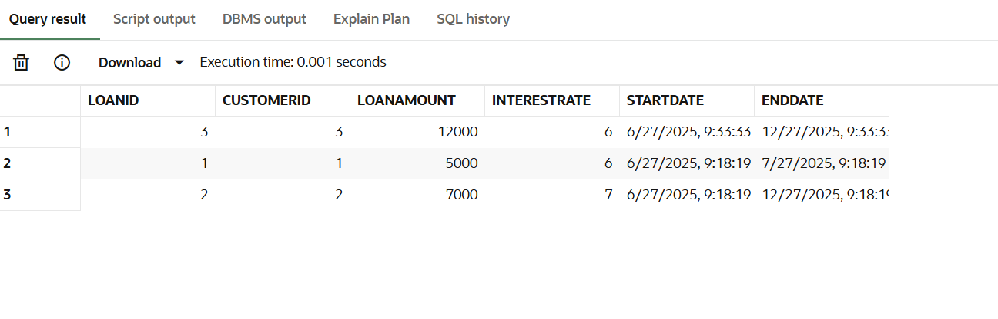

**-- scenerio-2 --**

ALTER TABLE Customers ADD IsVIP BOOLEAN;

BEGIN

  FOR cust IN (SELECT CustomerID, Balance FROM Customers) LOOP

    IF cust.Balance > 10000 THEN

      UPDATE Customers

      SET IsVIP = TRUE

      WHERE CustomerID = cust.CustomerID;

    END IF;

  END LOOP;

  COMMIT;

END;

/

SELECT * from CUSTOMERS;

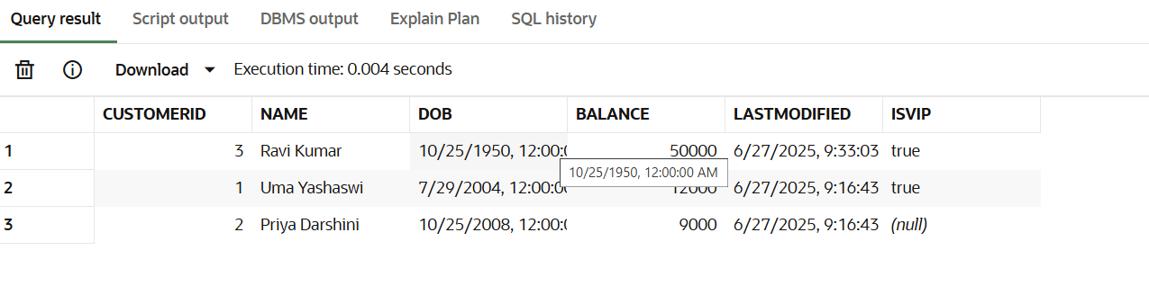

**-- Scenerio-3 --**

BEGIN

  FOR loan_rec IN (

    SELECT l.LoanID, l.CustomerID, c.Name, l.EndDate

    FROM Loans l

    JOIN Customers c ON c.CustomerID = l.CustomerID

    WHERE l.EndDate BETWEEN SYSDATE AND SYSDATE + 30

  ) LOOP

    DBMS_OUTPUT.PUT_LINE('Reminder: Loan ID ' || loan_rec.LoanID ||

                         ' for customer ' || loan_rec.Name ||

                         ' is due on ' || TO_CHAR(loan_rec.EndDate, 'YYYY-MM-DD'));

  END LOOP;

END;

/

